Star Wars website – Client-side mockups

Felipe .M Iglesias



CONTENT

EXECUTIVE SUMMARY 2

KEYFRAMES AND JAVASCRIPT 3

MEDIA 7

# EXECUTIVE SUMMARY

In this document we are going to develop the client side technical information. We will describe and showcase where implementing client-side dynamic content would be a valuable asset for the website.

# KEYFRAMES AND JAVASCRIPT

**KEYFRAMES**

**Crawling Letters**

We will implement a keyframe on the about.php that is imitating the crawling letters of the movies introduction. In this section using this animation we will explain what the Star Wars universe and the original trilogy is about.

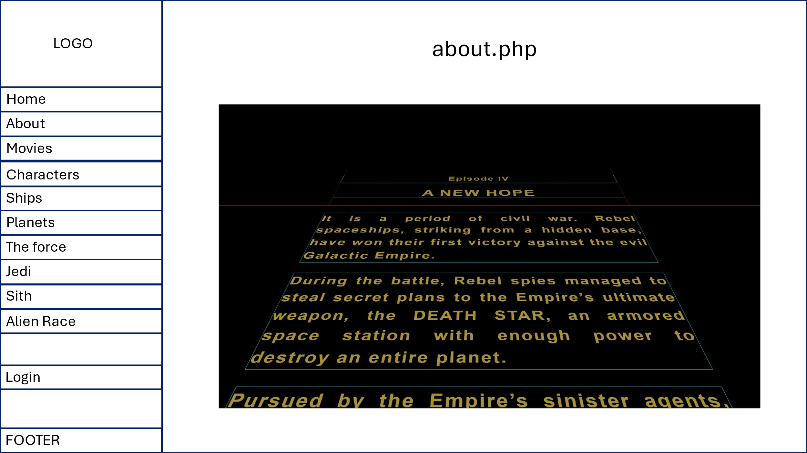

**HOVERS**

**On data display containers**

For navigating through the data display sections and hover over a data record we choose a **transform : scale(1.03);** and **border: 2px solid rgba(0, 255, 255, 0.7);** with a smooth **transition: all 0.3s ease-in-out;**

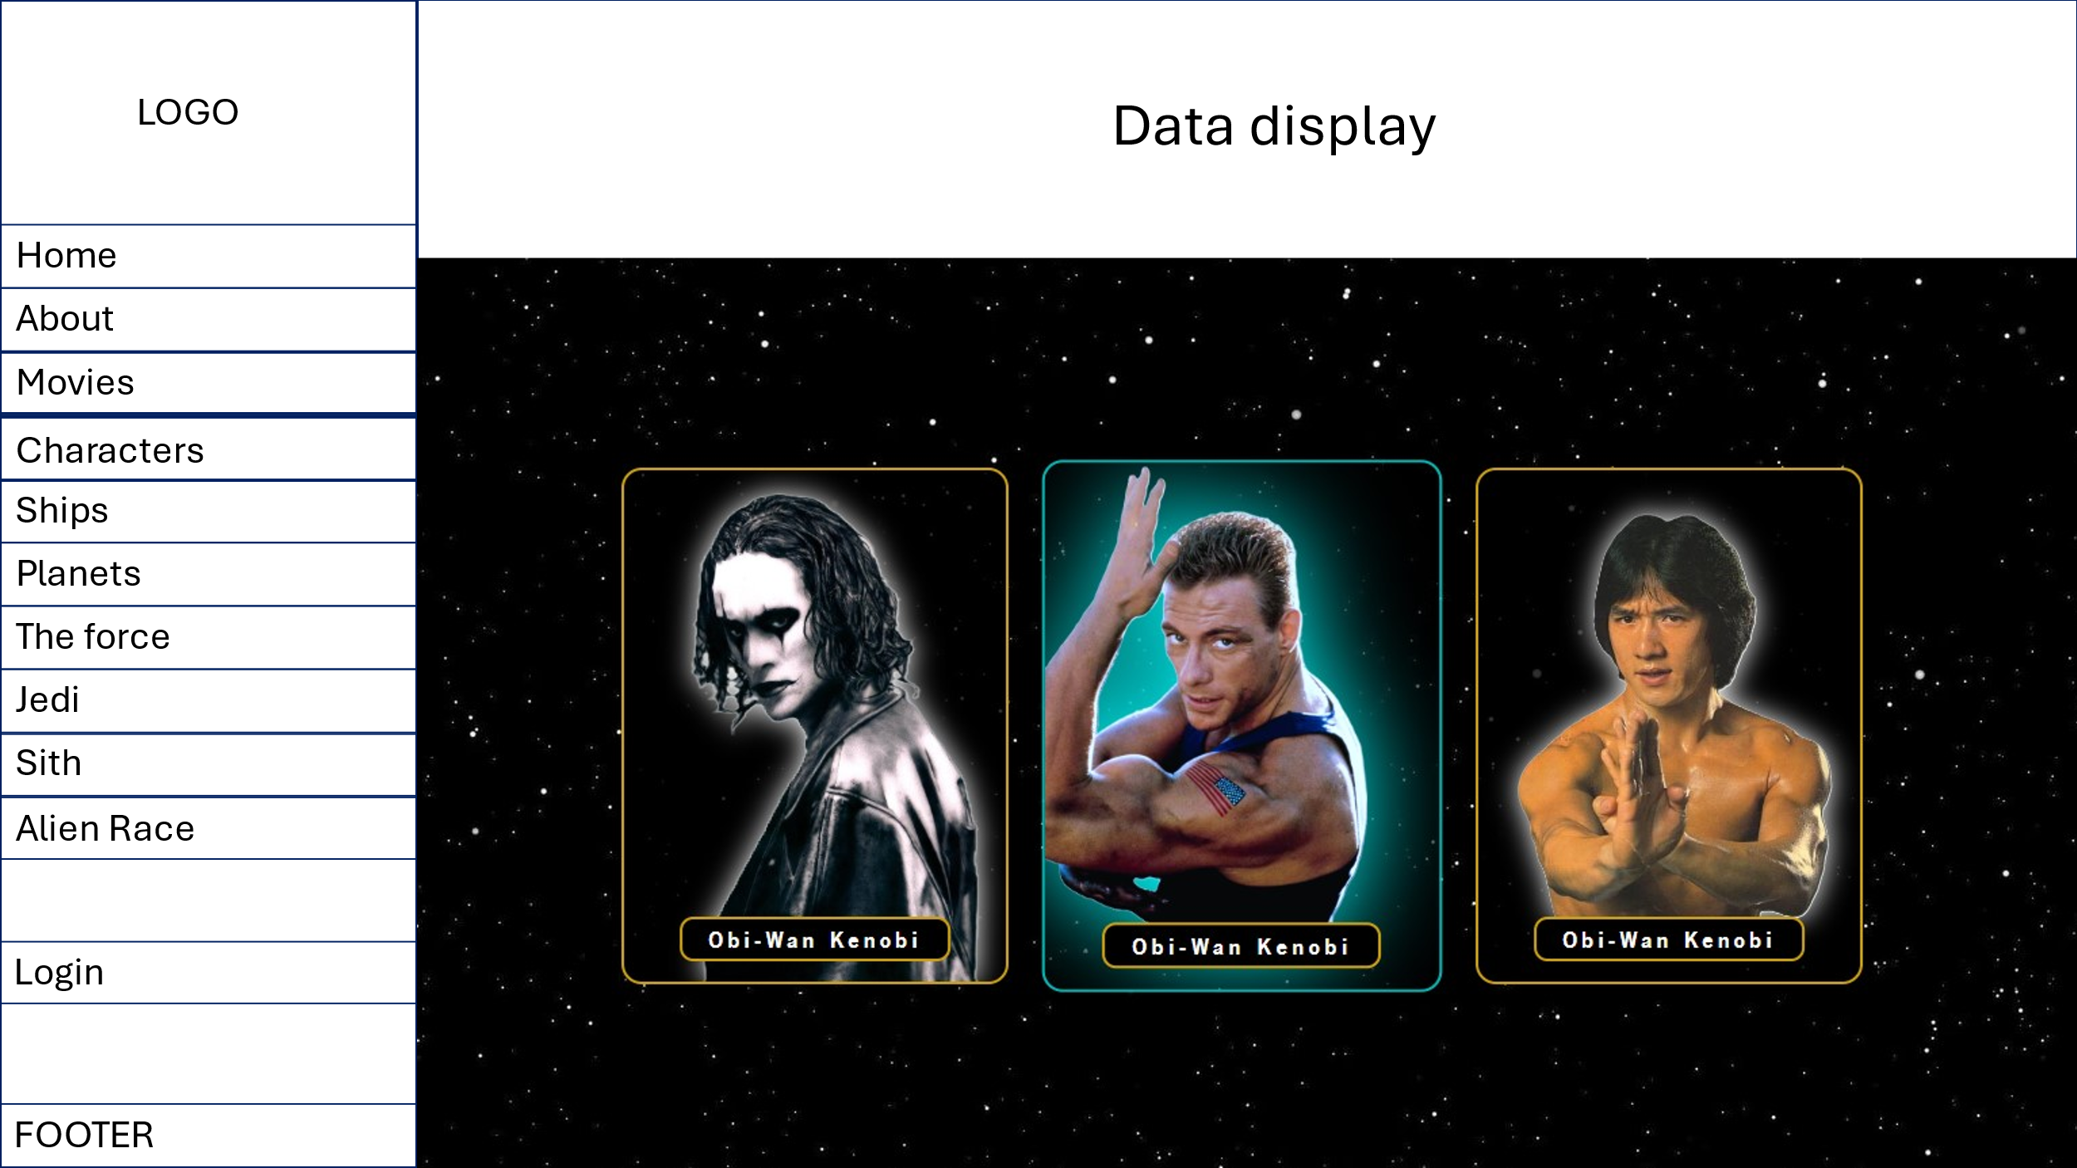

**DROPDOWN MENU**

**For the *sort data by* menu**

We will implement a dropdown menu to sort records in the display data sections.

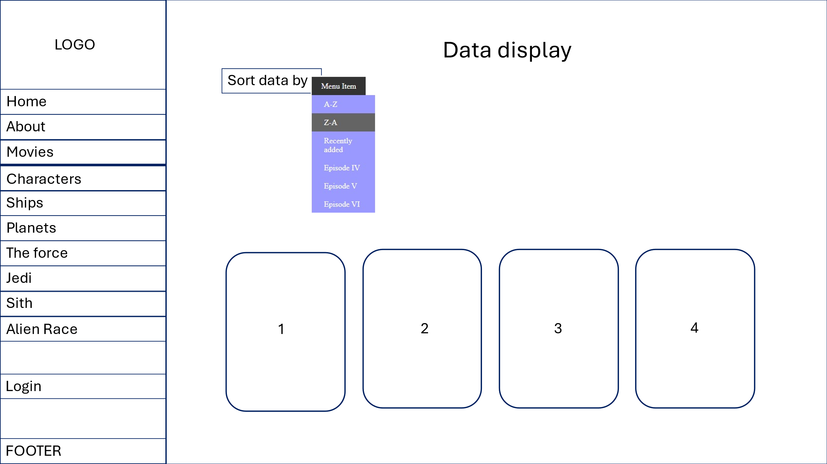

**JAVASCRIPT**

**Slideshows**

When clicking on a data record it will take us to another section with more information about, for the images display we will be using a simple slideshow built on JavaScript. We will have the capability of going to the previous and next image by clicking on the right and left arrows. In addition, it will automatically show the next image with an interval set on 6 second.

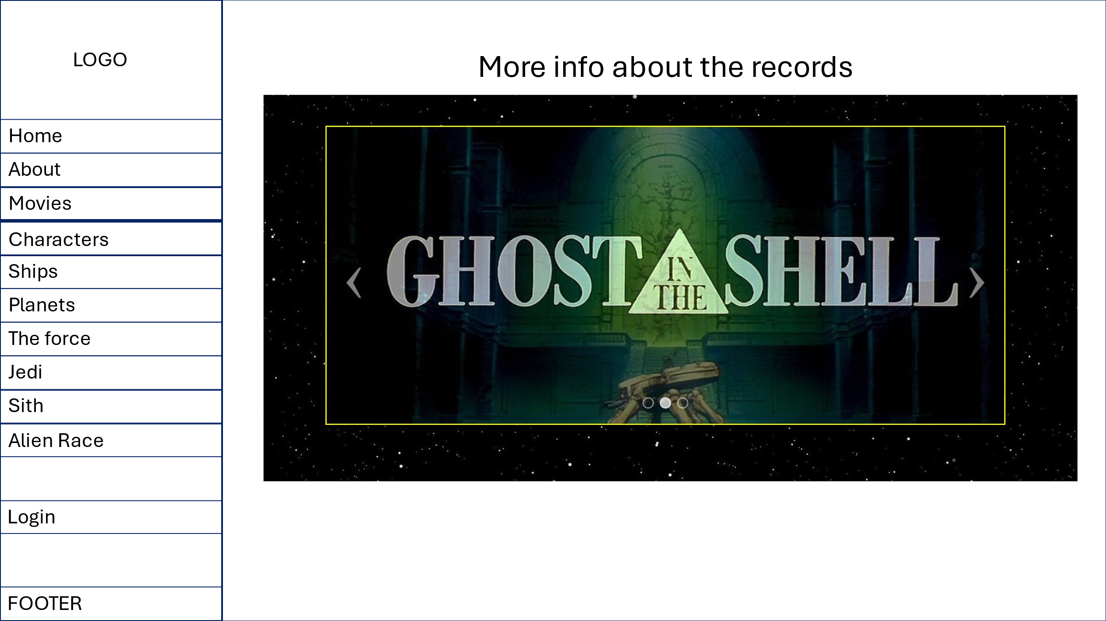

**Confirmation box – Delete**

When deleting a record, we will implement a pop up window to confirm it.

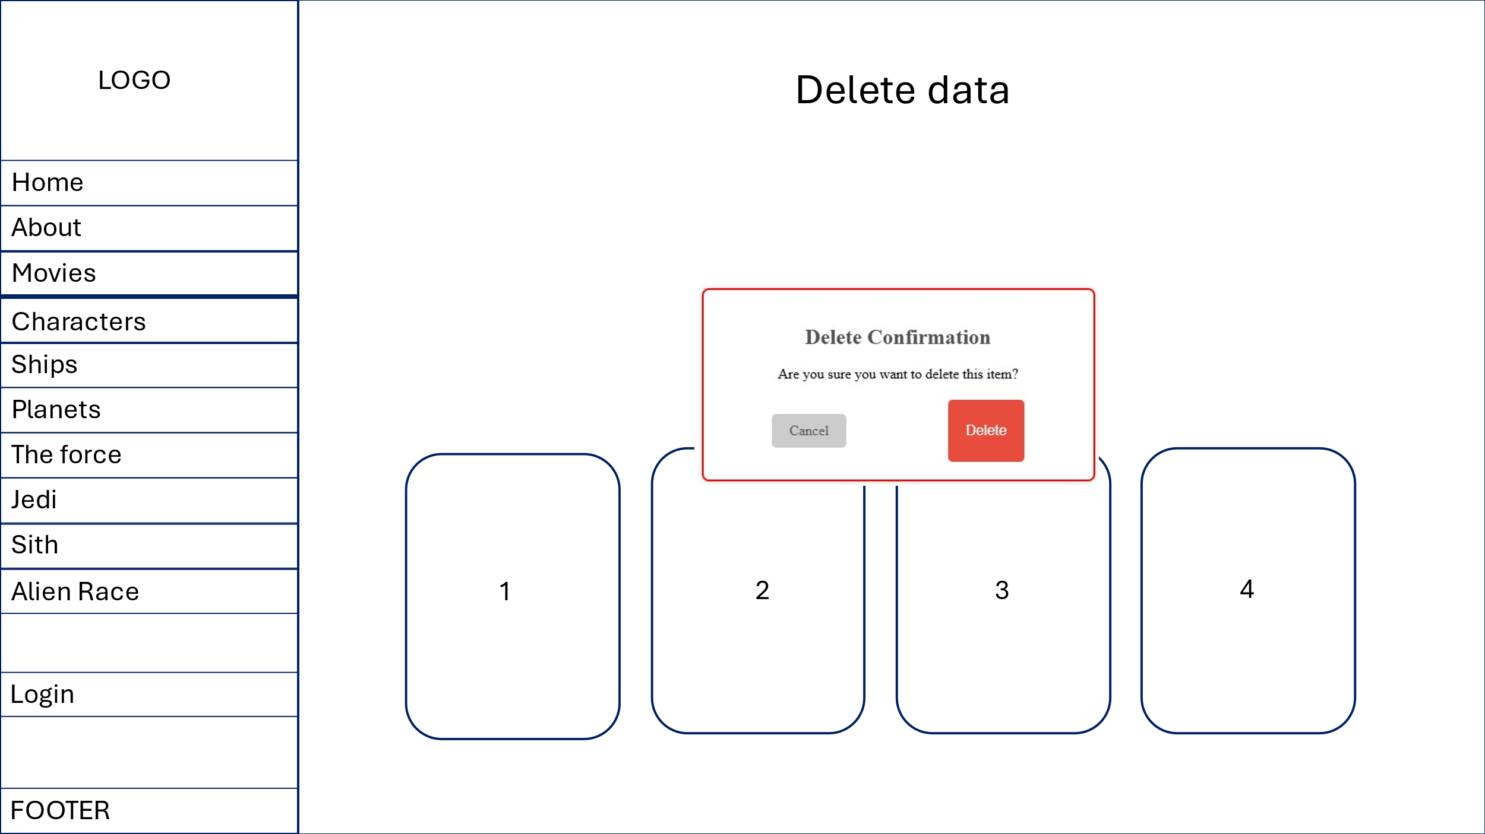

# MEDIA

On the Home section we will use a <video> as CTA, there will be some controls so the user can interact with the video.

